PROJECT ARCHITECTURE

ROLES AND RESPONSIBILITIES

Field | Details
Date | 26 June 2026
Team Id
Project Name | House Rent
Maximum Marks | 4 Marks

Roles and Responsibilities
The HOUSE RENT application consists of three main user roles: Tenant (Renter), Owner (Landlord), and Admin. Each role has specific responsibilities and permissions to ensure smooth operation of the platform.

1. Tenant (Renter)
The Tenant is responsible for searching and booking rental properties.
Responsibilities
- Register a new account and log in securely.
- Browse all available rental properties.
- Search properties using filters such as location, price, property type, and amenities.
- View complete property details and owner information.
- Submit booking requests for desired properties.
- Track booking status (Pending, Confirmed, or Cancelled).
- View booking history.

2. Owner (Landlord)
The Owner manages property listings and booking requests.
Responsibilities
- Register as an owner and obtain approval from the Admin.
- Add new rental properties.
- Update property details.
- Delete property listings.
- Manage property availability.
- View booking requests.
- Accept or reject tenant booking requests.
- Update booking status.

3. Admin
The Admin manages the overall platform and user activities.
Responsibilities
- Verify and approve Owner accounts.
- Manage all registered users.
- Monitor property listings.
- Enforce platform rules and policies.
- Handle reported issues and user complaints.
- Maintain platform security and data integrity.

Summary of User Roles
User Role | Responsibilities
Tenant | Search properties, view details, submit bookings, track booking status
Owner | Manage properties, update availability, approve or reject bookings
Admin | Approve owners, manage users, monitor the platform, enforce policies

Advantages of Role-Based Access
- Improves platform security.
- Provides controlled access to system features.
- Simplifies property management.
- Enhances user experience.
- Prevents unauthorized actions.

Example – Roles And Responsibilities Diagram:

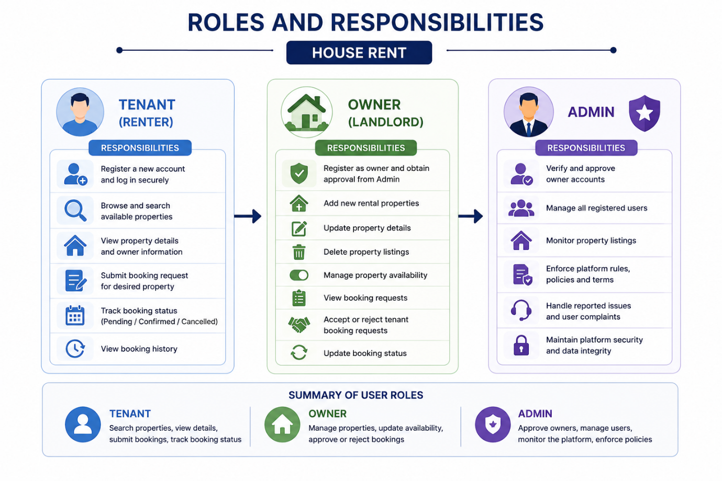

Figure 1: Roles And Responsibilities Architecture of the HOUSE RENT Application.

Reference:
- https://auth0.com/docs/manage-users/access-control
- https://www.mongodb.com/resources/languages/mern-stack-tutorial

